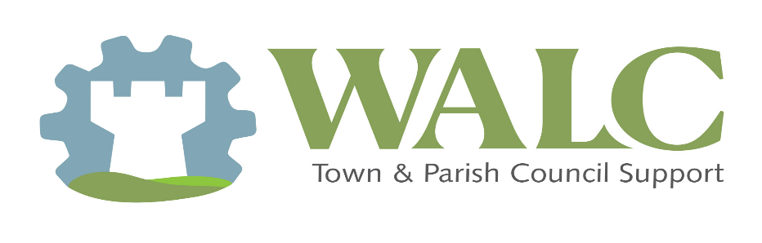

Why Parish Councils Should Establish a Youth Council
A County Association of Local Councils Perspective
County Associations of Local Councils strongly encourage parish and town councils to consider establishing a Youth Council as an effective, practical way of engaging young people in local democracy and community life.

Strengthening Local Democracy
Youth councils provide a structured and meaningful channel for young people to express their views on local issues that affect them. By involving younger residents early, parish councils help foster an understanding of democratic processes, decision-making, and civic responsibility. This early engagement supports the long-term sustainability of local democracy by nurturing future councillors, volunteers, and community leaders.

Improving Decision-Making and Representation
Young people experience their communities differently from adults. A youth council enables parish councils to access perspectives that may otherwise be overlooked, leading to more inclusive and informed decision-making. Issues such as recreation facilities, transport, environmental initiatives, community safety, and digital communication often benefit from youth insight. Listening to these voices helps ensure services and projects reflect the needs of the whole community.

Supporting Statutory and Strategic Objectives
Engaging young people aligns with the principles of the Localism agenda and supports councils’ duties around community engagement and equality. Youth councils also contribute positively to evidence for funding bids, neighbourhood plans, and community strategies by demonstrating active consultation and participation.

Building Skills and Confidence in Young People
Youth councils offer valuable opportunities for young people to develop leadership, communication, teamwork, and problem-solving skills. These are transferable skills that support education, employment, and wellbeing. Parish councils play a key role in enabling this development by providing light-touch support, mentorship, and a safe forum for participation.

Enhancing Community Cohesion and Reputation
Parish councils that actively involve young people are often viewed as more accessible, forward-thinking, and representative. Youth councils can act as ambassadors within schools and youth groups, helping to bridge generational gaps and strengthen community cohesion. This engagement can also reduce misconceptions about young people by highlighting their positive contributions.

Proportionate, Flexible, and Supported
Youth councils need not be complex or resource-intensive. Models can be adapted to suit local circumstances, whether advisory, project-based, or linked to existing youth provision. County Associations of Local Councils can provide guidance on governance, safeguarding considerations, terms of reference, and good practice, ensuring arrangements are proportionate and effective.

Conclusion
Establishing a youth council is a positive investment in the future of the parish. It strengthens democratic engagement, improves local decision-making, and empowers young people to take pride in their community. County Associations of Local Councils stand ready to support parish councils in developing youth councils that are inclusive, sustainable, and locally relevant.

